**Introduction**

**Background and problem**

People have moved from their countries for centuries, for all sorts of reasons such as escaping conflict, violence, poverty, or past or future persecution based on race, religion, nationality, and/or membership in a particular social group or political opinion. Nowadays, people also migrate to developed countries to seek superior healthcare, education, jobs and business opportunities. In 2013, the percentage of international migrants worldwide increased by 33% with 59% of migrants targeting developed regions (https://en.wikipedia.org/wiki/Human_migra

-tion). Many people go through difficult period in their adaptation which may be related to having lived under very different conditions and circumstances in their countries of origin. I firmly believe that similarities between the neighborhoods of people’s home and host countries might help them better adapt to the host country. Therefore, for this project I have picked one of the top migration corridors: Turkey – Canada and clustered neighborhoods by venues in their economic centers: Istanbul and Toronto. Clustering of neighborhoods might help migrants to

find similar neighborhoods in Toronto and accelerate the adaptation process in their host country.

**Migration facts**

According to Canadian Census data, in the period of 1980 – 2013 more than 30.000 Turkish nationals migrated to Canada for different reasons. The majority of Turkish Canadians live in Ontario, mostly Toronto. The graph below shows the trend of immigration from Turkey to Canada in the period between 1980 and 2013:

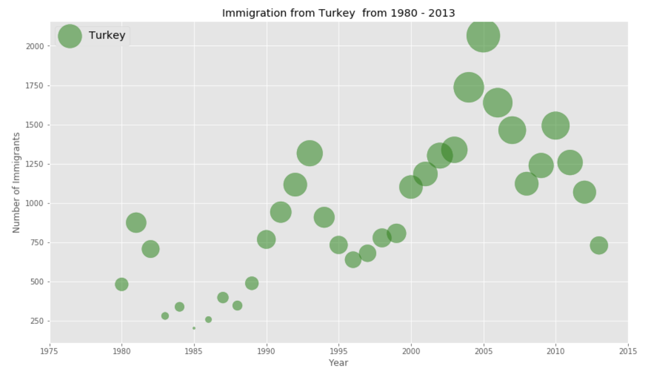

It is seen from the graph that immigration from Turkey to Canada peaked in 2005 with more that 2.000 migrants. The potential reason of decrease in immigration to Canada after 2005 might be that Turkey’s EU membership negotiations officially launched after intense bargaining. The process of softening EU’s immigration policies for Turkish citizens might cause them to prefer EU countries over Canada for migration. Nevertheless, the overall trend of migration from Turkey to Canada is upward:

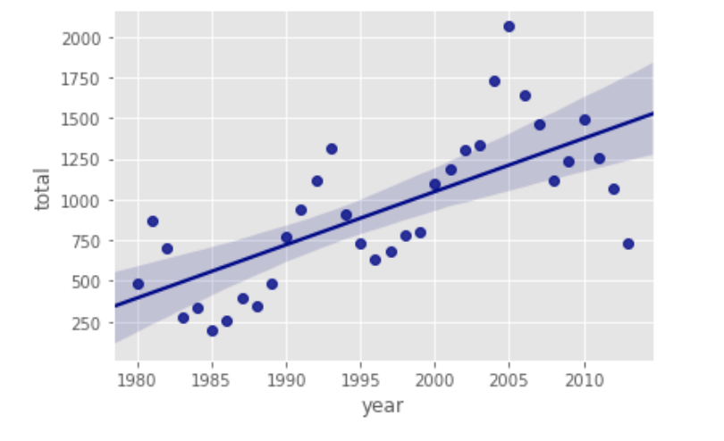

**Data**

Data of this project come from different sources. Migration data was retrieved from Statistics Canada (https://www12.statcan.gc.ca/census-recensement/index-eng.cfm?MM=1). After cleaning data and extracting yearly data for Turkey, I used Python “matplotlib” and “seaborn” libraries to obtain visualizations above.

The next task was to obtain data of Toronto’s neighborhoods. To do so, I used several libraries to scrape Wikipedia page (https://en.wikipedia.org/wiki/List_of_postal_codes_of_Canada:_M) which contained the list of postcodes in Toronto (*i.e. BeautifulSoup4, lxml, html5lib*). Then I downloaded coordinates of each postcodes from *colc.us* and constructed a final data set which looked like this:

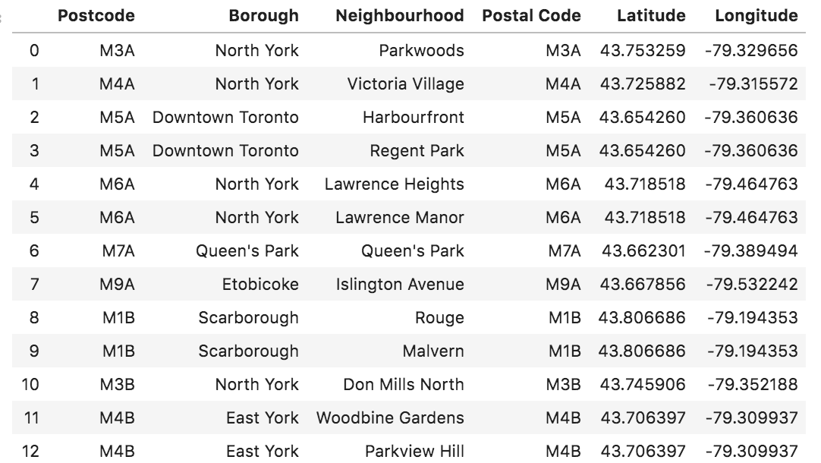

Next, I needed to obtain the list of Istanbul’s neighborhoods with latitudes and longitudes. I extracted Istanbul’s 39 neighborhoods with coordinates from a web page (https://worldpostalcode.com/turkey/istanbul/). I couldn’t automate this process using Python’s scrapping libraries, as every neighborhood was a hyperlink and it was needed to click on it to see its coordinates. Therefore, I manually collected coordinates of Istanbul’s 39 neighborhoods:

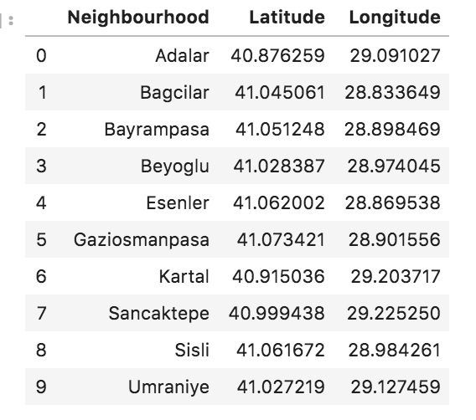

Lastly, I extracted data on venues in both cities from Foursquare. I applied two criteria for venue data: venues had to be within 500m radius of the neighborhood and the maximum number of venues around the neighborhood was limited to 100. The final data contained names and coordinates of neighborhoods, and names, coordinates and categories of venues in both cities.

